Scenario 1 –
Query 1 –

SELECT
t1.transaction_id AS t1_id,
t1.sender_account AS sender,
t1.receiver_account AS receiver,
t1.amount AS sent_amount,
t1.transaction_time AS sent_time,
t2.transaction_id AS t2_id,
t2.sender_account AS returned_sender,
t2.receiver_account AS returned_receiver,
t2.amount AS returned_amount,
t2.transaction_time AS returned_time
FROM
transactions t1
JOIN
transactions t2
ON
t1.sender_account = t2.receiver_account
AND t1.receiver_account = t2.sender_account
AND t2.transaction_time BETWEEN t1.transaction_time AND DATEADD(day, 1, t1.transaction_time)
AND t2.amount BETWEEN t1.amount * 0.9 AND t1.amount * 1.1
ORDER BY
t1.transaction_time;
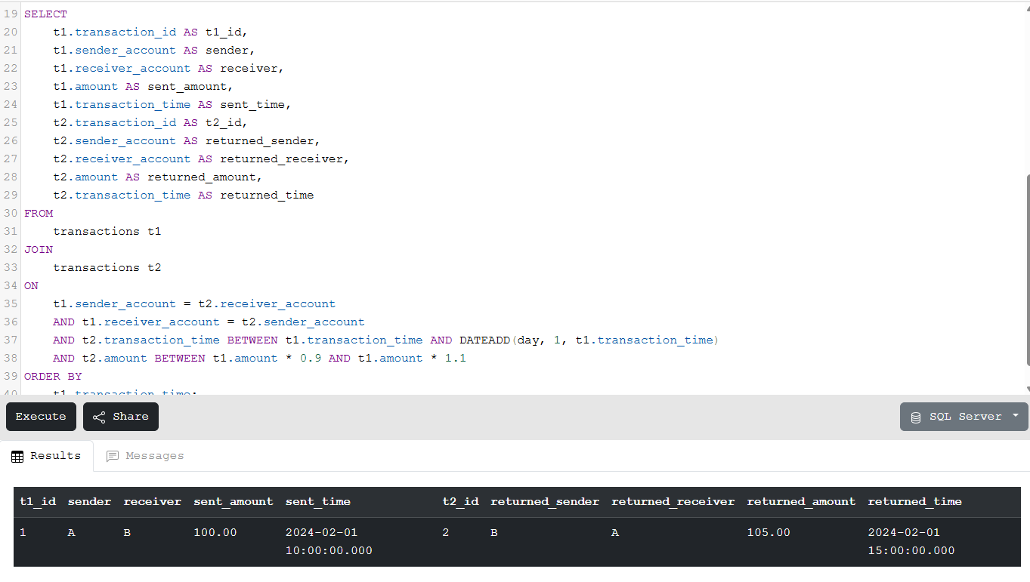
Database SS –
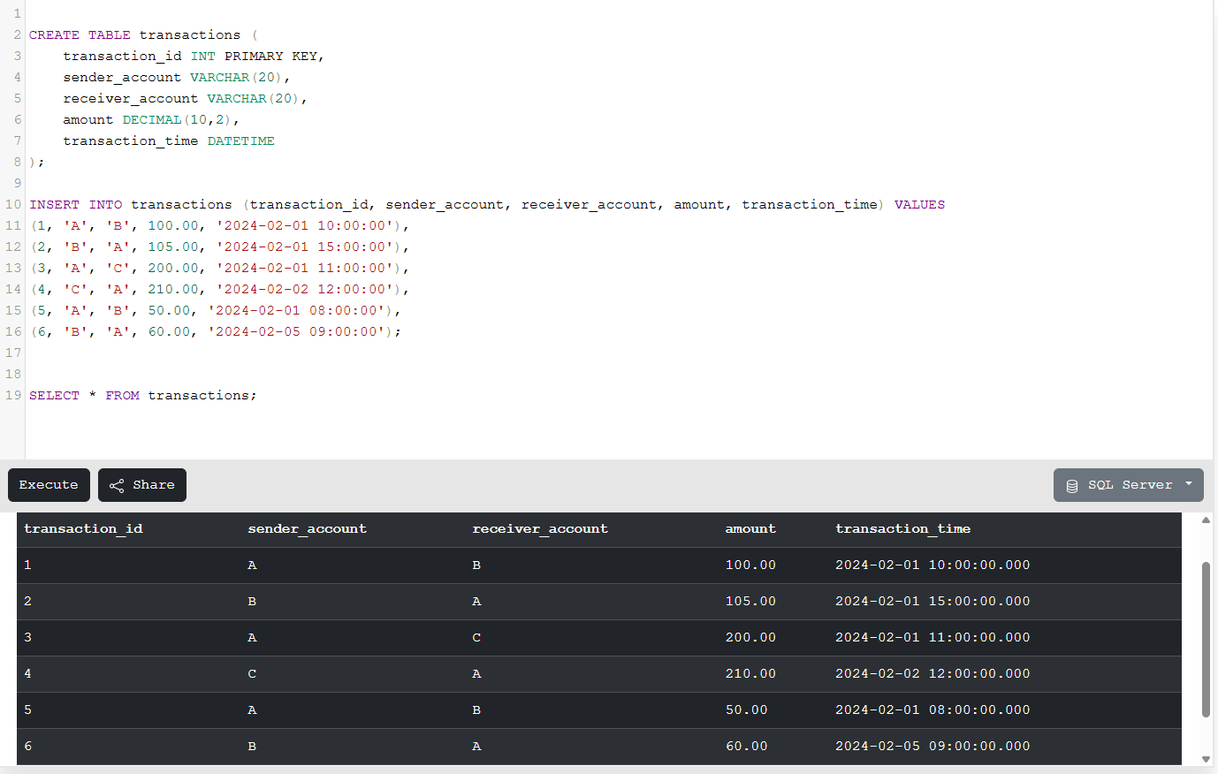

Scenario 2 –
Query –
WITH streaks AS (
SELECT
player_name,
match_date,
runs_scored,
ROW_NUMBER() OVER (PARTITION BY player_name ORDER BY match_date) -
ROW_NUMBER() OVER (PARTITION BY player_name, CASE WHEN runs_scored >= 30 THEN 1 ELSE 0 END ORDER BY match_date) AS grp
FROM ipl_matches
),
streak_groups AS (
SELECT
player_name,
MIN(match_date) AS streak_start,
COUNT(*) AS streak_length
FROM streaks
WHERE runs_scored >= 30
GROUP BY player_name, grp
)
SELECT
player_name,
streak_start
FROM streak_groups
WHERE streak_length >= 3
ORDER BY player_name, streak_start;

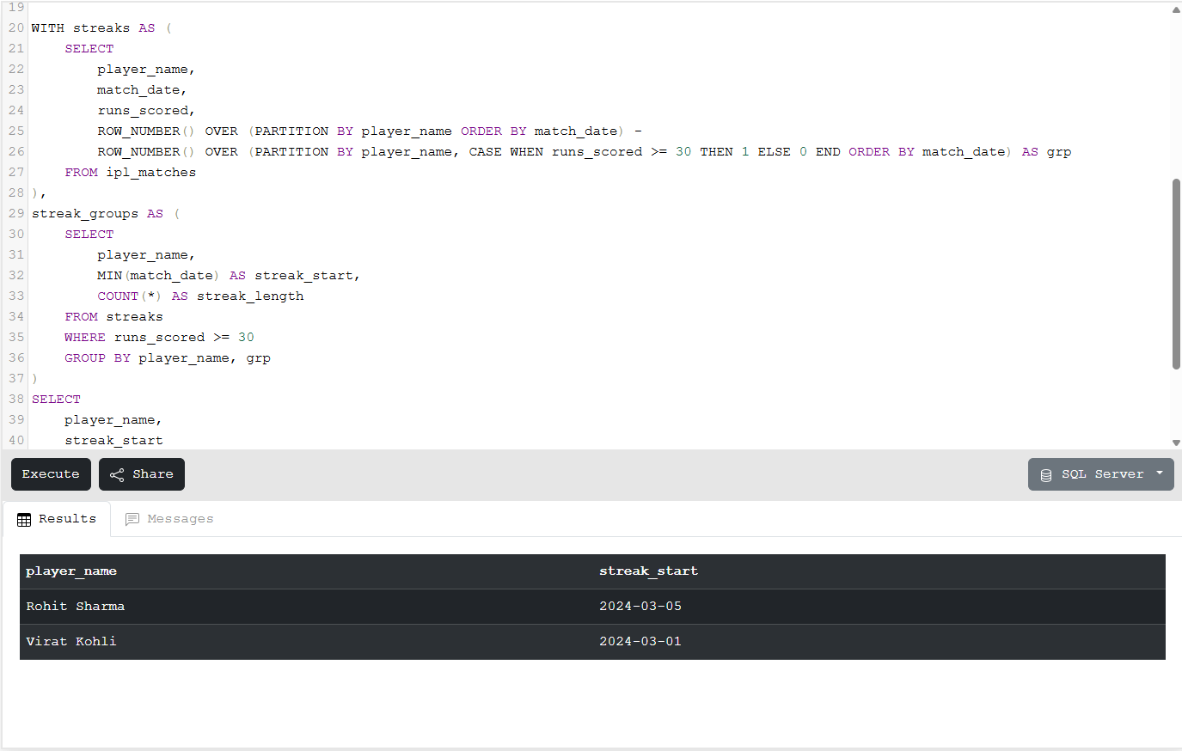

Database SS –
